SPIRE & LIGHT United Churches
United Benefice of St Keverne, St Ruan with St Grade,
& St.Wynwallow (The Lizard)
www.spireandlight.com

Sunday 23rd October 2022

Trinity 19 Bible Sunday –
Readings – Isaiah 45:22-25; Psalm 119:129-136; Romans 15: 1-6; Luke 4:16-24

9.30am – Morning Prayer - St. Peter’s, Coverack
9.30am – Holy Communion – St.Ruan, Ruan Minor
11am – Holy Communion - St.Keverne
11.15am – Family Service – St.Wynwallow, The Lizard

Please note there will be no Zoom services for a number of weeks.
Further updates in later newsletters.

Diary Dates
*Home group cancelled this week – see below*
Monday 10.30am - The Home Group in Victoria House are NOT meeting on Monday, 24th, as a number of participants have other commitments. A venue for the following week, 31st, has yet to be decided.

Tues. October 25th 2.30pm– St.Keverne Church Lady Chapel – Corporate Prayer meeting - to pray for our church's for love, unity and holiness.
Please contact John Wilks for more info. (Also on November 22nd)

Next Sunday – Oct 30th

11am - All Saints/All Souls - United Benefice at St.Wynwallow Church, The Lizard

If you would like to order your charity Christmas Cards early,
Margaret and Arthur Jackson will be holding an Open Day on Sat 22nd Oct, 10am -4pm at Penmennor, Trelyn Rd, St Keverne.
There will be an almost full range of sample cards to view and order from, through Traidcraft. The cards benefit other charities too, such as Cafod, Red Cross, and others.
We look forward to seeing you.

Traidcraft News
Dear Traidcraft Supporters,
People in our parish who have ordered through me in the past, can still do so. I have a few of the new Autumn Gift Leaflets with new Christmas items etc, and one lone catalogue, left from Spring 2022. Many of the items in that catalogue will still be available but may be at a different price.
Estelle will find the correct prices re the items you wish to order, and let me know the correct amounts to pass on to you. So please feel free to ask to look at an Autumn leaflet or the Spring Catalogue, but sadly, they will have to be returned to me to lend out again, as they are in scarce supply.
With many thanks for your support for this very worthwhile charity.
Margaret Jackson
01326 280 108
margarthur75@gmail.com

On the Way Prayer Group
Every Wednesday at 5 pm a group of people from around our Deanery have been praying together via Zoom.
The prayers are diverse and are not solely in respect of the On the Way process.
If you would like to be part of this prayer initiative then please contact Mary Cooper, Churchwarden at Mullion Church. Her email is mcooperbrown@gmail.com
The prayer meeting only lasts for a short while and all who participate feel very blessed by being part of the group.

The Prayer Spot

A Message from Sam Buchannan
Please pray for all those in our community who need Gods help in this difficult time we find ourselves in. Pray for the people of the Ukraine who need Gods help in this difficult time they find themselves, that they will have Gods help in their lives. Pray for all those who need hospital treatment that God will be present with them and meet all their needs. Pray for our church members that God will be with them in this difficult time-that God will be with them and give them guidance in their lives and pray for all our Benefice that God will enter into our lives and remind us that we are all brothers and sisters in Christ with a charge to be there for each other. Be encouraged that when you pray God will answer your prayers in Jesus Christs name.
Here is a prayer for you to say - How great O God are your riches? How deep are your wisdom and knowledge? Who can explain your decisions? Who can understand your ways? For all things were created by you and for you. To God be the glory for ever Amen
Read James 5-13-20

A Reflection from Revd John Ough

Dear friends,
It is good to be back from our holiday. I find them exhausting but enjoyable! As we returned, we noticed how much the season of autumn had progressed down here in Cornwall in our absence. In our Christian calendar we have reached Bible Sunday. Part of our holiday was spent in North Wales, not far from Bala, where one the founders of the British and Foreign Bible Society lived. In fact, we saw a Blue Plaque to Thomas Charles, honouring the fact that he lived in Bala.
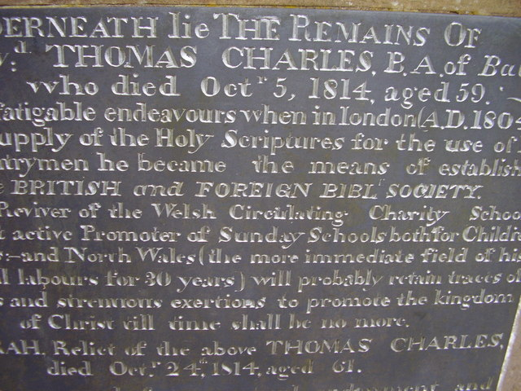
Thomas Charles was so moved by a young girl called Mary Jones, who walked twenty miles over the mountains of North Wales to get a Bible from him. This inspired him on his mission to bring God’s word to all and the work of the Bible Society has continued through the generations since. During World War 1 alone, the Bible Society distributed more than 9 million copies of scripture to both armed forces personnel and prisoners of war, in many different languages. These would have brought comfort and strength and hope at a time of crisis to those who read them.
We live in an age of flux, where standards of the past ages have been increasingly ignored or deemed not relevant for the present age. However, we believe that the Bible has contained within its pages eternal truths which we ignore at our peril. Having been a teacher for some twenty years I have had the privilege of being present when thousands of Gideon Bibles have been given out in Secondary Schools. Students have taken them home and my hope and prayer has always been that they might open and read the word of God.
This Thursday as I started to reflect and think about what I should say in this week’s reflection, I felt for our politicians at this time of uncertainty, as they are responsible for policies that affect so many people’s lives. We depend on good government. I pray that God would direct this nation and all nations in the ways of truth, justice and of peace. I long for our country to return to Christian values. Such a longing should be foremost in the hearts of all Christians, as we seek to reflect God’s love in a country and a world of so much need.
May the Lord speak to all of us afresh through his Living Word this autumn.
Pastoral Letter from Revd Geoff Davis – Interim Minister for Kerrier Deanery

‘Thank you‘ and ‘Here we go, here we go, here we go!’
Dear All,
Firstly, I want to thank all of those who were able to attend my licensing service at Breage Church on the 25th September and also to everyone who remembered me in their prayers. It was a wonderful welcome into the Deanery, I am delighted to be on board and as I said above, ‘my goodness, ‘Here we go...........!’
I also want to say a huge thank you to your outgoing Rural Dean David Miller. What a dear man, who has been so faithful a servant to you all. A Pastor with a big heart who has so fulfilled his calling for the past 29 years in the Deanery as Parish Priest and of course with the additional responsibility as your Rural Dean. I so enjoyed my meetings with him and am disappointed not to have the opportunity of ministering with him. We shall indeed all remember him in our prayers as he takes up this new and exciting ministry in Southampton.
To date I have had the privilege of officiating at Germoe, Sithney, St Keverne with Coverack, Porthleven, Breage and Wendron. I am looking forward to preaching at a United Benefice Services for All Souls at St Wynwallow and then later in the day at St Mawgan. Then comes my first visit to Helston on Remembrance Sunday.
To my reckoning that will be meeting some of all you dear faithful people in 16 of the 23 Churches - here we go indeed! I may well have that calculation wrong perhaps someone can put me right?!
The Words that I have been reading from the Bible at the beginning of all the services have been St Paul’s to the Church at Corinth (1Corinthians 2vs 1-5). Do read them for they so clearly express how I come to you and what my constant prayer is as we meet together.
I do thank God for each and every one of you and will endeavour to do all I can under the leading and guiding of the Holy Spirit to fulfil my vow for the ‘cure of souls’ across the Deanery throughout my time with you. Seeking always and only to give all the glory to our Heavenly Father, our Lord and Saviour Jesus Christ and the Gracious Holy Spirit in what we hope and pray they might yet do in and through us and even me!
I remain in His service for you all
Geoff
‘On we go......’

